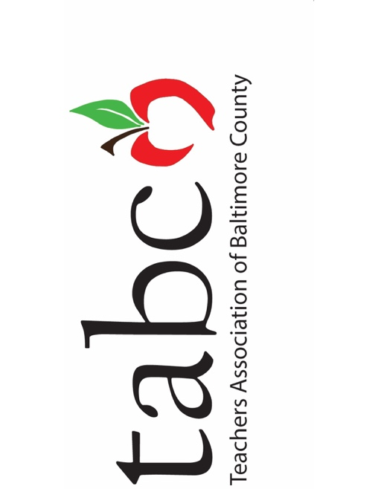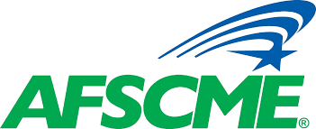
Local 434

Earlier today the presidents of the five bargaining units met to discuss the plan for action from Baltimore County Public Schools (BCPS) as it relates to the school closures. All of the presidents advocated for the staff’s welfare in the following ways.

- Schools and offices are closed with no building access of any employee with the exception of essential staff.
- 10-month and 12-month employees do not report to work and are not required to work from home.
- 10-month and 12-month employees shall be paid in accordance with the pay schedules.
- Essential and essential as needed employees should be compensated in accordance with their Collective Bargaining Agreements.
- As part of Governor Hogan’s executive order, there should be no gatherings greater than 25. As a result, schools and offices should be closed in order honor social isolation of the disease as well as provide opportunity for building cleaning and sanitation.

There is no follow-up relating to spring break. Updates will be shared as they are available.

In solidarity,

Cindy Sexton, TABCO
Jeannette Young, ESPBC
Bryan Epps, AFSCME
Nick Argyros, OPE
Tom DeHart, CASE

