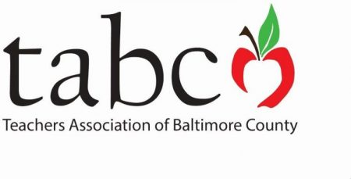
TABCO
Minority Affairs Committee

BLACK LIVES MATTER AT SCHOOL
WEEK OF ACTION

Black Lives Matter at School is a national coalition of educators, parents, students, and community partners who want to make sure that everyone is treated fairly, regardless of their race, ethnicity, or religion.

Please join us to kick-off the week of action. A diverse panel of students will share their experiences as students in this age of youth activism and awareness.

TABCO Office
1220 East Joppa Road, Building C, Suite 514, Towson, MD 21286

Saturday, February 1, 2020
10:00 am – 1:00 pm

Light refreshments and a variety of resources will be
provided to families and educators.

Please contact Stacie Strickland by January 30th to reserve your space:
sstrickland@mseanea.org 410-828-6403

